Example of codes used in the Semantic HTML for SEO and Accessibility post

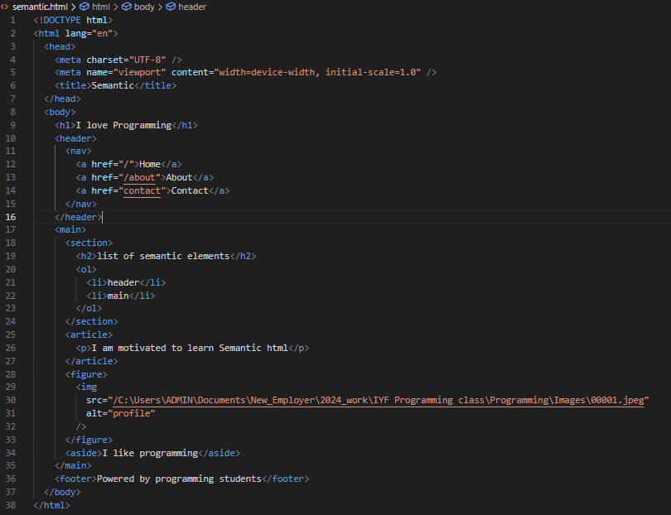

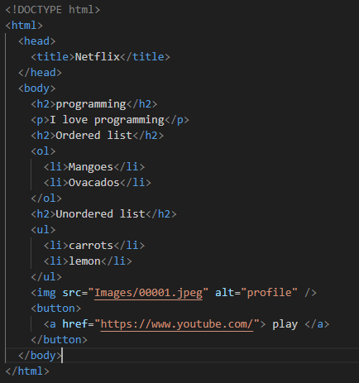

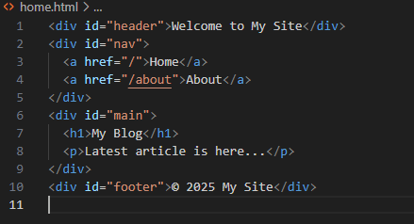

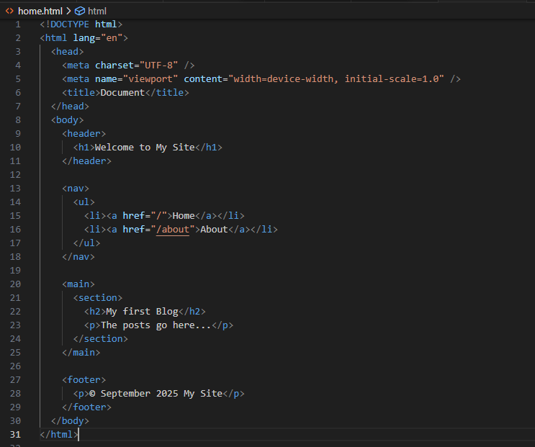

**Non-semantic code- before**



It displays

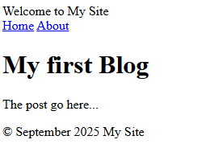

Has no semantic meaning for improved screen reading and SEO indexing.

**After using semantic codes**



It shows

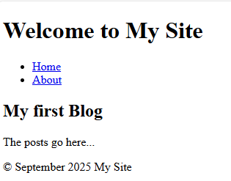

Replacing the <div> with semantic tags boosts the Website accessibility and SEO

**Before: Making forms using non-semantic codes**

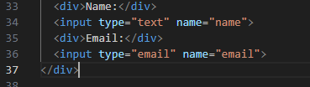

This gives

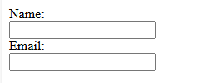

**After- using semantic codes**

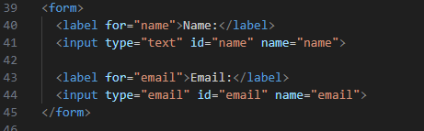

It appears, as shown below, with improved readability: there is improved use of semantic tags <form> and <label> that boost usability.

